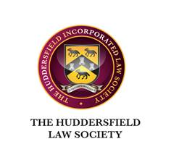

**THE HUDDERSFIELD & DEWSBURY INCORPORATED LAW SOCIETY**

BUILDING SAFETY ACT 2022 CONVEYANCING TRAINING

**Monday 10th July 2023**

**2.00 to 5.00pm (Arrive 1.45 for light refreshments – please note that no lunch is provided)**

**£20 pp for Members / £25 pp for Non-Members**

**Chadwick Lawrence Solicitors**

13 Railway St, Huddersfield HD1 1JS

We are delighted to invite you to a special workshop, tailored to our Law Society, delivered by property expert, Ian Quayle

To confirm your place and to arrange payment, please email **SallyAnn Masih at** [**sallyannmasih@schofieldsweeney.co.uk**](mailto:sallyannmasih@schofieldsweeney.co.uk)by **Friday 30 June 2023**